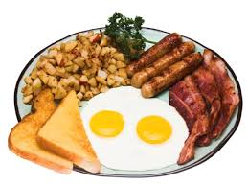Name______________________________________________ Period_________

BREAKFAST

Breakfast can be broken into two words: __________________ & ________________.

When talking about a human diet, fasting is a period of time when you don’t _____________________ or _________________________. So, breakfast is the first meal you eat after a period of not eating.

Think about what time you ate last yesterday. About what time was that?_________

What time was the first time you ate something today?________ How many hours did you go without food or “fast”?_____________________

**Breakfast really is the most important meal of the day**. Not only does it give you energy to start a new day, but breakfast is linked to many health benefits.

***The benefits of eating a healthy breakfast are:***

|  |  |  |
| --- | --- | --- |
| 1. | 2. | 3. |
| 4. | 5. | 6. |

Traditional breakfast foods around the world are different. ***Common breakfast foods in the USA*** are:

|  |  |  |
| --- | --- | --- |
| 1. | 2. | 3. |
| 4. | 5. | 6. |

***Here are some other countries breakfast traditions. Circle any of the foods you would consider eating for breakfast.***

Japan: Rice, boiled fish, miso soup (soybeans with salt and a fungus, and sometimes rice or barley

France: toasted baguette with jam/honey/butter/Nutella

Malaysia: coconut rice, anchovies, hot sauce, peanuts, and boiled egg

Switzerland: cheese, cold cuts, butter & jam, soft boiled eggs, coffee, tea, fresh fruit

Mexico: Chilaquiles (tortilla chips simmered in mole) or tripe with eggs

Turkey: Feta, tomato, cucumber, olives, toast, cherry jam, spicy Turkish sausage, Turkish tea

Scotland: Full Scottish breakfast (fried egg, back bacon, sausage links, black pudding, buttered toast,

baked beans and scones.

**“MY PLATE “ is a visual of the food groups and portions of foods you eat for a balanced meal.**

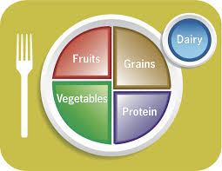

Importance of each “MY PLATE” CATEGORY.

1._______________- important skin, nails and muscles. This also helps make you feel “satisfied” longer

than just simply eating grain products. Protein comes from meat, fish, eggs,

poultry, nuts, & dried beans.

2. _________________ & ____________________- There are many essential vitamins and minerals

In this group. They can reduce your risk of heart disease, diabetes, stoke, high

blood pressure and cholesterol. They are also high in vitamin C which is good for

building your immune system and helping with gums and repair of skin tissue.

3. ______________- This group is a great source of B vitamins, fiber, iron & magnesium. These

can assist with maintaining a healthy nervous system, reduce the risk of

constipation and can help reduce cholesterol. Foods in this group include:

bread, rice, cereal & pasta.

4. ______________-This group contains calcium which is good for bone health and preventing

Osteoporosis- (weakening bones). Foods in this group include: milk, cheese,

& yogurt.

Name___________________________________________ period________

Listed below are a variety of common foods eaten for an American breakfast. Write the names of each food listed into the proper category of **MY PLATE**.

CEREAL TOAST BACON

MILK BANANA BAGEL

HAM SAUSAGE ORANGE JUICE

POP TART FRUIT SMOOTHIE HASH BROWN POTATOES

YOGURT STRAWBERRIES V8 VEGETABLE JUICE

|  |
| --- |
|  |

PANCAKES SCRAMBLED EGGS CHEESE (ON OMLET)

|  |
| --- |
| Vegetables |

|  |
| --- |
| Dairy |

PEANUT BUTTER MUFFIN DICED GREEN PEPPERS (IN OMLET)

|  |
| --- |
| Grains |

|  |
| --- |
| Protein |

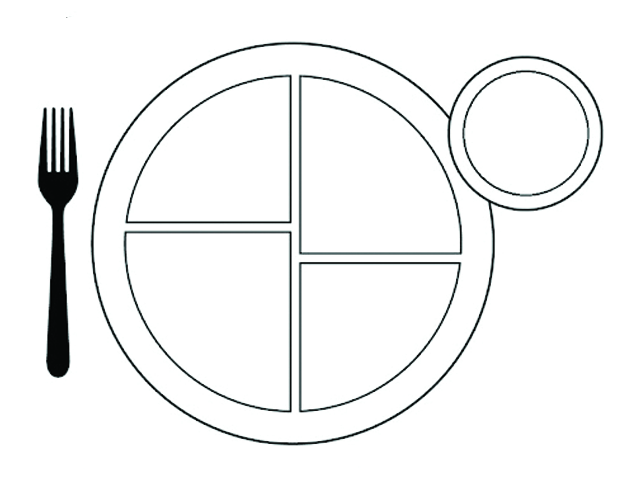

Fruit